Developers:

* Conrad Sanderson – Data 61 group – Innovative data group in Australia
* Ryan Curtin – From GaTech
* Collaborated with NICTA – National ICT Australia – Australia’s largest Information Communications Technology Research Centre of Excellence.

https://www.nicta.com.au/about-nicta/

1. The library aims to have a good balance between speed and ease of use, and is useful if C++ is the language of choice (due to speed and/or integration capabilities), rather than another language like Matlab or Octave. In particular, Armadillo can be used for fast prototyping and computationally intensive experiments, while at the same time allowing for relatively painless transition of research code into production environments
2. A **delayed evaluation approach is employed** (during compile time) to combine several operations into one and reduce (or eliminate) the need for temporaries. This is accomplished through C++ template meta-programming. Performance comparisons suggest that the library is considerably faster than Matlab and Octave, as well as previous C++ libraries such as IT++ and Newmat.

**Performance results from Technical report**

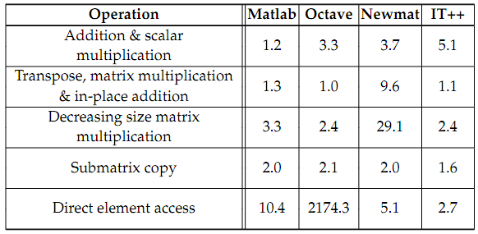

Performance compared to Armadillo. Operations are performed on Matrices of different sizes 1000x800, 800x600,600x400,400x200.